Very high cycle fatigue properties of high strength steel

Ichiro Suzuki¹, Takashi Nakamura¹*, Tatsuo Sakai² and Hiroyuki Oguma³

¹ Division of Mechanical and Space Engineering, Hokkaido University, Japan
² Department of Mechanical Engineering, Ritsumeikan University, Japan
³ Research Center for Structural Materials, National Institute for Materials Science, Japan

* Corresponding author: nakamut@eng.hokudai.ac.jp

INTRODUCTION
This document is a template and contains information on all the style and formatting required for the final brief paper. The paper should be A4 size, and the margins should be top/bottom: 25.4 mm and left/right: 19.05 mm. The major font sizes and styles used in this template are: 1) Title: Arial 14 pt bold; 2) Author names: Arial 12 pt; 3) Affiliation(s): Arial 10 pt italic; 4) Corresponding author: Arial 10 pt; and 5) Main text: Arial 11 pt, justified. The final brief paper should be from 2 to 6 pages long with clearly defined sections, such as a brief introduction, experimental procedures, results and discussion, and conclusions. Skip one line before each paragraph, but do not indent paragraphs. You can add figures and tables to show significant findings. After finalizing the final brief paper, please access the VHCF8 website and submit it as a PDF file (.pdf) less than or equal to 10 MB.

Sections and subsections should be given brief headings, and each heading should appear on its own separate line. The style and size of headings are: 1) Main: Arial 11 pt bold and upper-case letters (e.g., “EXPERIMENTAL PROCEDURE”, “RESULTS AND DISCUSSION”); 2) Secondary: Arial 11 pt bold and capitalize the first word (e.g., “Fatigue test results”).

FIGURES AND TABLES
Figures and their captions
Figures, such as photographs, graphs, and illustrations, should be presented with sufficiently informative captions placed below them. Figures should not be low in resolution, and their captions should comprise a brief title and a description of the figure. The size and style of the caption are Arial 11 pt. All figures should be referred to as “’Fig.’” and numbered consecutively in the text.

Tables and their captions
Tables should also be presented with sufficiently informative captions. The captions should be above the table, and the size and style are the same as for figures. All tables should be referred to as “Table” and numbered consecutively in the text.

ACKNOWLEDGEMENTS
Acknowledgements, if necessary, should be included before the references.

REFERENCES
References should be quoted in the text with a number in square brackets such as [1]. All references should be listed at the end of the manuscript in the order they appear in the text. The appropriate reference styles are shown in “References.” For four or more authors, use the first named author followed by “et al.”

- Sakai T. et al., In: Zimmermann M. and Christ H.-J., eds. Seventh International Conference on Very High Cycle Fatigue, DVM, Dresden, 2017; 57–62.
- Yoshinaka F. et al., Fatigue Fract Eng Mater Struct. 2019; 42: 2093–2105.
- Oguma H. and Nakamura T., Int J Fatigue. 2013; 50: 89‒93.
- Murakami Y., Metal Fatigue: Effects of Small Defects and Nonmetallic Inclusions, Elsevier Ltd. 2019.

Table 1 Mechanical properties of high strength steel.

0.2% proof stress [MPa] | Tensile strength  [MPa] | Elongation  [%] | Reduction of area  [%]
1400 | 2140 | 11 | 44

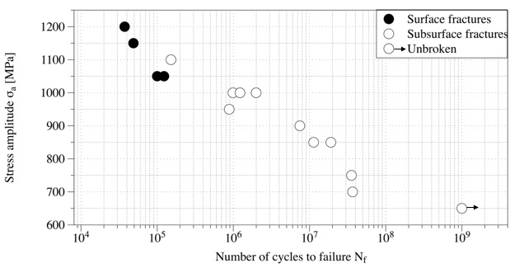

Fig. 1 S-N plots of the material used.

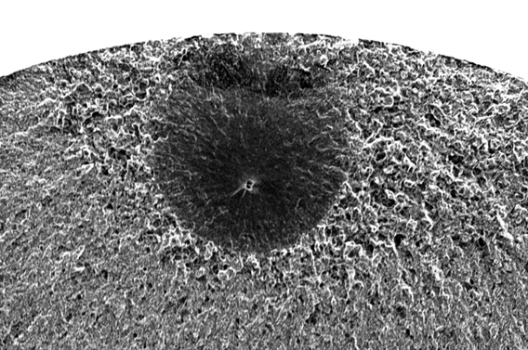

Fig. 2 Subsurface fracture surface.

